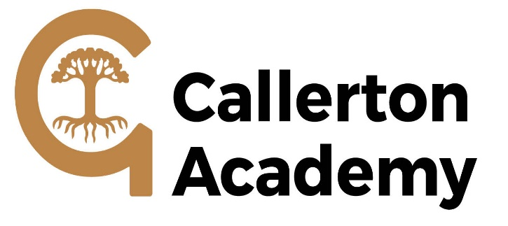

 | JOB DESCRIPTION
SCHOOL: | Callerton Academy
POST TITLE: | Lunchtime Supervisor
GRADE | N2
RESPONSIBLE TO: | Facilities Manager
JOB PURPOSE: | To ensure the safety and welfare of students on the academy site during the lunch break.
MAIN DUTIES: | The following list is typical of the level of duties which the postholder will be expected to perform. It is not necessarily exhaustive and other duties of a similar type and level may be required from time to time.
1. Supervision of students taking a school meal as well as other students on site during the lunch break.
2. Liaise with kitchen staff to ensure that students with special dietary needs are provided with the correct meal.
3. Maintaining discipline throughout the lunchtimes break in accordance with guidance given by senior staff and to report back accordingly.
4. Ensuring that an accurate record of incidents is maintained using appropriate procedures, such as incident book or accident book, in order to fulfil the Academy’s legal obligations.
5. The supervision of students returning to the premises at the end of the lunch break in the rare occasion that this will happen.
6. To promote and implement the academy’s equal opportunities policies in all aspects of employment and service delivery.
7. To assist in maintaining a healthy, safe and secure environment and to act in accordance with the Academy’s policies and procedures.

