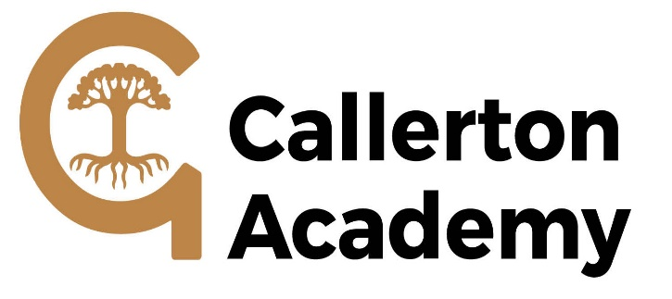

JOB DESCRIPTION

DIVISION: | Callerton Academy
POST TITLE: | Support Assistant – Higher Level
GRADE: | N6
RESPONSIBLE TO: | SENCO
RESPONSIBLE FOR: | Support Assistants as required
JOB PURPOSE: | To support and assist teachers as part of a professional team to contribute to raising standards of pupils’ achievement and to undertake a range of teaching and learning activities under the professional direction and supervision of a qualified teacher, in line with the school’s policies and procedures.
MAIN DUTIES: | The following list is typical of the level of duties which the postholder will be expected to perform. It is not necessarily exhaustive and other duties of a similar type and level may be required from time to time.

- Teaching and Learning activities

- To help pupils make progress in a range of classroom settings, including working with individuals, small groups and whole classes where the assigned teacher is not present.

- To be aware of national frameworks, typical curricula and teaching methods and expectations in the relevant key stages of phases and make effective use of other learning activities to support the development of pupils’ skills.

- In line with the school’s policy and procedures, to use behaviour management strategies which contribute to a purposeful learning environment.

- To organise and manage safely the physical teaching space and resources for which he/she is responsible.

- To use ICT effectively to support learning activities and develop pupils’ competence and independence in its use.

- To support the role of parents in pupils’ learning and contribute to/lead meetings with parents to provide constructive feedback on pupil progress/achievement, etc.

- Planning, Monitoring and Assessment

- Within an agreed system of supervision, to plan challenging teaching/learning objectives and deliver learning activities to pupils, making adjustments according to pupil responses/needs, as appropriate.

- To produce lesson plans, worksheet, plans, etc.

- To support teachers in selecting and preparing teaching resources that meet pupils’ needs and interests.

- To support teachers in evaluating pupils’ progress through a range of monitoring and assessment activities.

- To maintain and analyse records of pupils’ progress.

- To provide feedback to pupils and colleagues on pupils’ learning and behaviour.

- To contribute to identifying and to undertake appropriate out of school learning activities which consolidate and extend work carried out in class.

(c ) Support for Pupils

- To communicate effectively and sensitively with pupils to support their learning.

- To develop and implement Individual Education Plans and assess the needs of pupils, using detailed knowledge and specialist skills to support pupils’ learning.

- To respond to pupils’ individual needs and promote inclusion and acceptance of all pupils in the classroom.

(d) Other Duties

- Under the supervision of the Principal or other designated teachers, to invigilate internal and external examinations.

- Following the school guidelines for absent teachers, provide cover for lessons under the agreed system of supervision.

- To undertake planned supervision of pupils’ out of school hours learning activities and supervise pupils on visits and trips.

- To administer, assess and mark tests.

- To supervise other support assistants in the classroom as required.

- To comply and assist with the development of policies and procedures relating to child protection, health, safety and security, confidentiality and data protection, reporting concerns to an appropriate person.

- To establish constructive relationships and communicate with other agencies/professionals, in liaison with the teacher, to support achievement and progress of pupils.

- To attend meetings and engage in development activities/training as required by the school.

- To promote and implement the school’s equal opportunities policies in all aspects of employment and service delivery.

(e) Child Protection

1 The postholder will have responsibility for promoting and safeguarding the welfare of children and young persons s/he is responsible for, or comes into contact with.

